https://www.amny.com/nyc-transit/illegal-vending-thrives-brooklyn-bridge/

Defying a NYC ban, illegal vending thrives on iconic Brooklyn Bridge this summer

By Barbara Russo-Lennon

amNewYork

posted August 26, 2025

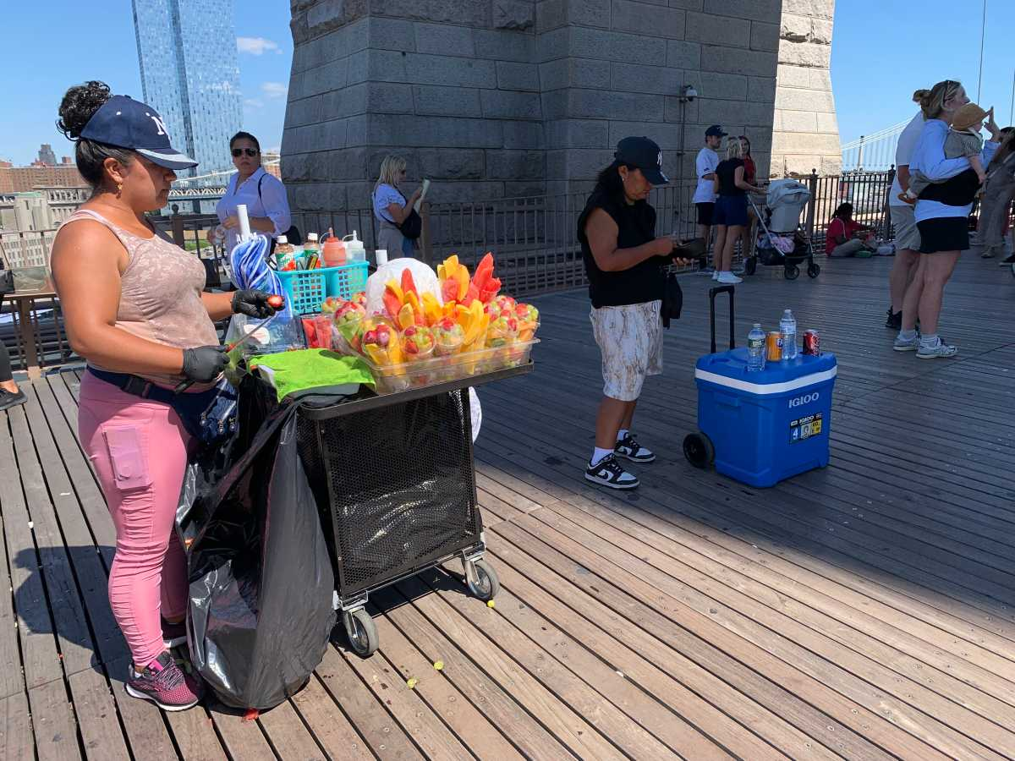
Vendors on the Brooklyn Bridge. Photo by Barbara Russo-Lennon

Just over a year after Mayor Eric Adams and transit officials banned illegal street vending on the Brooklyn Bridge, the vendors are back. Scores of illegal vending carts selling everything from hats to souvenirs to food lined the walkway on a recent Monday afternoon.
amNewYork visited the landmark bridge several times this month, most recently on Aug. 25. Before even stepping on to the walkway of the iconic East River crossing, five vendors were eagerly selling baseball caps, fruit and water to passersby.

But the vending action heated up once a reporter stepped onto the span to do the classic mile-long walk from Manhattan to Brooklyn. Over 30 illegal vendors blocked parts of the narrow walkway, which at its widest point is only 16 feet. Most vendors were concentrated on the Manhattan side and the center of the bridge. But still, hawkers optimized space on the Brooklyn side, too.

‘It’s part of the NYC experience,’ tourists say
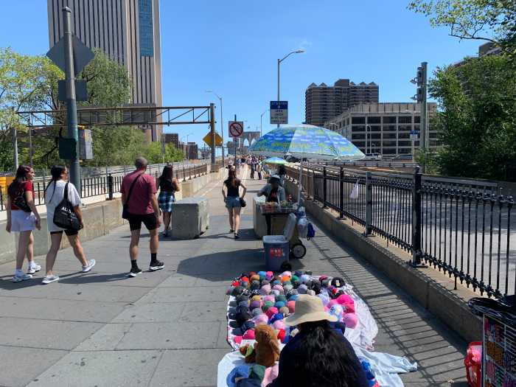Vendors at the Brooklyn Bridge. Photo by Barbara Russo-Lennon

As hundreds of people walked the historic bridge, happily snapping photos of the scenic skyline, the vendors peddled their wares.

Lisa, a tourist from London, browsed the goods. She did not mind the makeshift vending taking up space on the Manhattan side of the bridge.

“It’s fun and part of the NYC experience,” she said.

Miguel was walking across the bridge with his family when he stopped to buy a fruit snack on a sunny day.

“It’s very refreshing to buy cold fruit when you go over the bridge, especially on a very hot day,” he said with a smile.

A vendor getting ready for work. Photo by Barbara Russo-Lennon

Despite the support for the vendors, vending on the bridge is illegal.

Last year, Mayor Adams conducted a major push to announce new rules clarifying that vending on pedestrian walkways on the Brooklyn Bridge, and all DOT bridges, is prohibited. Officials cited pedestrian safety, as well as bridge security, as reasons for the ban.

“New York commuters as well as the millions of people who visit our city each year should be able to enjoy the Brooklyn Bridge without impediments to safety and pedestrian mobility,” DOT Commissioner Ydanis Rodriguez said last year. “These rules would make it safer and easier for pedestrians to travel across what’s considered America’s Eiffel Tower and take in the world-renowned view of New York Harbor.”

amNewYork reached out to the DOT to see if the ban is still in effect. The agency confirmed that the ban is still active, but deferred follow-up questions to the NYPD.

amNewYork is awaiting a response from police for this story.

